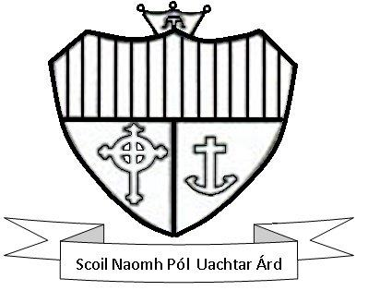
Application Form to Enrol
St. Paul’s Secondary School
2022/2023

Closing Date for Applications 12th November 2021

Please Note:
Applicants should read the school’s Admission Policy, which is available on www.stpaulsoughterard.com prior to completing the application form. The information requested on the application form is required in order to process your application for admission to the school. The information provided by you will be treated confidentially and processed in line with the school’s Admission Policy. Any personal data provided on this form will be used to (i) identify applicants (ii) process an application in line with the school’s admissions policy (iii) communicate with parents/guardians in respect of an application (iv) notify parents/guardians of the outcome of an application. The information will be retained for an appropriate period thereafter to address any potential queries arising from the application process or added to the student’s school file in the case of successful applicants. In accordance with section 66(6) of the Education Act 1998, as amended, personal data relating to applications for admission may be shared with the board of management of another school or the patron in order to facilitate the efficient admission of students. This information may include the date on which an application was received by the school, the date on which an offer was made and the date on which an offer was accepted. Personal information concerning applicants may also be shared, including their name, address, date of birth and PPS number. Further information on the handling of your personal data, including how to exercise your rights under GDPR, is set out in the school’s Data Protection Policy, which is available on www.stpaulsoughterard.com

Name of Applicant

Gender

Address

Date of Birth

PPS Number

Current Primary School

Proposed Year of Entry  (Please tick the year) | 1st TY  2nd 5th  3rd 6th

Mother’s Name

Address

Eircode
E mail address

Mobile Number

Home Phone Number

Father’s Name

Address

Eircode
E mail Address

Mobile Number

Home Number

I (We) wish to apply to enrol my (our) son/daughter ___________________________ in St. Paul’s Secondary School in September 2022.

In accepting an offer of admission from St. Paul’s Secondary School, you must indicate—

- whether or not you have accepted an offer of admission for another school or schools. If you have accepted such an offer, you must also provide details of the offer or offers concerned (indicate details if applicable below)

and

- whether or not you have applied for and awaiting confirmation of an offer of admission from another school or schools, and if so, you must provide details of the other school or schools concerned (indicate details if applicable below)

Signed:______________________________ Signed:____________________________
Date:_______________________________ Date:_____________________________
Closing Date for Applicants: 12th November 2021 (for 2022 applicants)
For Office Use Only
Date Application Received

School Stamp

